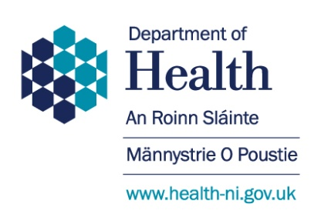

Subject:  Discount Rates for 2023-24  PES (2023) 10 | Circular Reference: HSC(F) 42-2023  DoH Reference: HE1/23/470925  Date of Issue: 12 December 2023
For Action by:  Directors of Finance of HSC bodies and NIFRS  For Information to:  Chief Executive of HSC bodies and NIFRS  Summary of Contents:  HMT PES (2023) 10 paper on Discount Rates for 2023-24  Enquiries:  Any enquiries about the contents of this Circular should be addressed to:  Heather McComb  Department of Health (DoH)  Financial Accounting Unit  Room D3.10  Castle Buildings  Stormont  BELFAST  BT4 3SQ  Tel: 028 90 765600  Heather.mccomb@health-ni.gov.uk | Related documents:  PES (2023) 10  PES (2023) 10 Annex C Combined rates  Superseded Documents:  HSC(F) 38-2022  Expiry Date:  31 December 2024  Status of Contents:  Action  Implementation:  Immediate

Discount Rates for 2023-24

- Department of Finance (DoF) have issued the HM Treasury Public Expenditure System (PES) paper 2023 (10), enclosed within the issuing email to this circular. This paper sets out the discount rates to be used as at 31 March 2024 in valuing general provisions, post-employment benefits, financial instruments and leases (under IFRS 16).

Action Required

- Please disseminate this information to relevant staff within your organisations for action as appropriate.

- The PES Papers are not available on the DoF or DoH websites as they are Treasury documents, providing guidance for internal use only. As such, please ensure that this information is circulated to all relevant staff. We would also ask that you do not make these papers available on your own external websites.

If you have any queries in relation to this circular please contact Heather McComb at Heather.mccomb@health-ni.gov.uk or Tel: 028 90 765600.

Jacqueline Keating
Financial Accounting Unit

