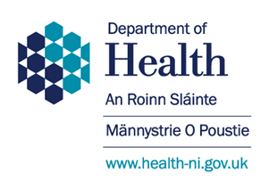
We must improve the care
for people who have had a stroke
in Northern Ireland

At the moment

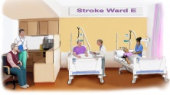
- some people don’t get important treatments or have specialist staff in their local hospitals
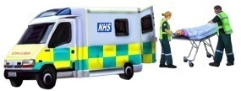
- some people do not get to the right place soon enough for treatments that could help

We need your views to help us make changes in the best way

All options for change will cost more money

A stroke is when the brain is damaged because the blood supply to the brain is stopped

This can happen from a bleed when a blood vessel bursts
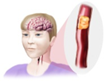
or because an artery to the brain becomes blocked by a clot in the blood

Stroke can cause problems – e.g.

 | movement |  | thinking, and memory
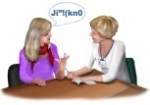 | communication |  | eyesight
 | coordination |  | mood

Good stroke services means -

- Not as many people die from a stroke
- People with stroke have less disability afterwards
- People make a better recovery from their disabilities with rehabilitation (therapy for getting better)

Research tells us what works best -

We need a few highly specialist centres for the best treatments immediately after a stroke

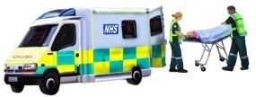
We need to get people there very quickly -

some treatments have to be given in the first few hours

We need stroke units to give rehabilitation after the first few days

We need the rehabilitation to carry on after people leave hospital

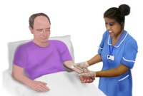
We need the stroke staff to see enough patients so that they are experts
…but not too many so the services are too busy

There are 6 options to think about -

Option A  5 Hyperacute (Highly Specialist) Units  5 Acute Stroke Units  - different wards in the same hospitals | 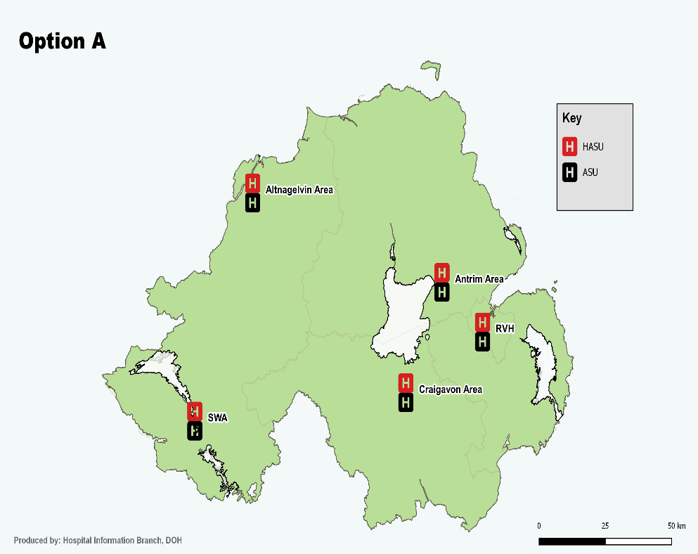
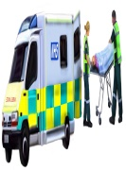  Travel time to a Hyperacute (Highly Specialist) Unit | 99% people - the journey is  less than 1 hour
Things to think about | There are not enough patients in 4 hospitals to develop skills

Option B  4 Hyperacute (Highly Specialist) Units  4 Acute Stroke Units  - 4 different wards in the same hospitals…  …with a potential 5th ward in the Ulster Hospital | 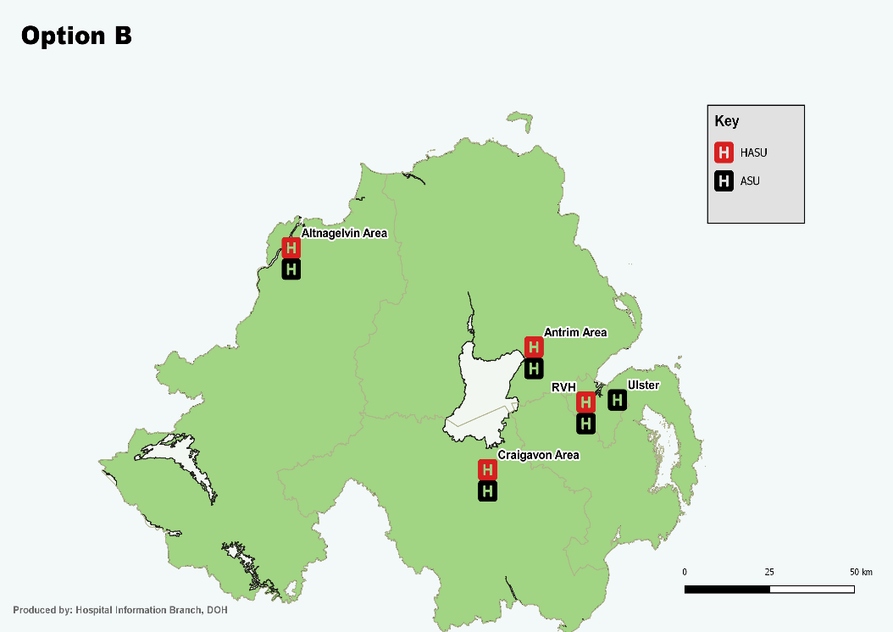
Travel time to a Hyperacute (Highly Specialist) Unit | 94% people – the journey is  less than 1 hour
Things to think about | There are not enough patients in 2 hospitals to develop skills

Option C  4 Hyperacute (Highly Specialist) Units  4 Acute Stroke Units  - 4 different wards in the same hospitals…  …with a potential 5th ward in the Ulster Hospital | 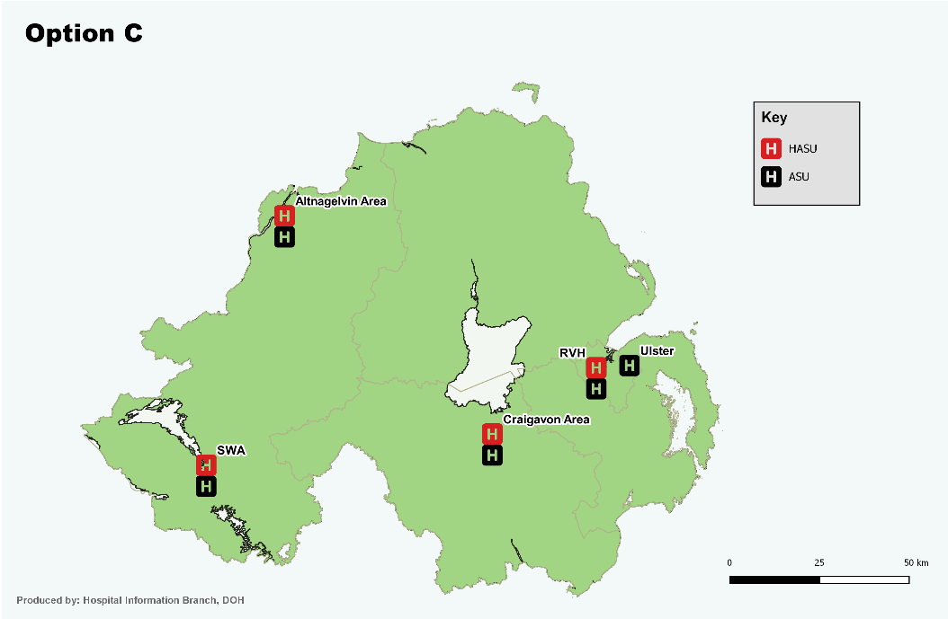
Travel time to a Hyperacute (Highly Specialist) Unit | 98% people – the journey is  less than 1 hour
Things to think about | There are not enough patients in 3 hospitals to develop skills

Option D  Phase 1 4 Hperacute (Highly Specialist) Units  Stage 2 3 Hyperacute (Highly Specialist) Units  Close the Antrim specialist unit  4 Acute Stroke Units with a possible 5th unit at the Ulster Hospital | Make changes in 2 phases -  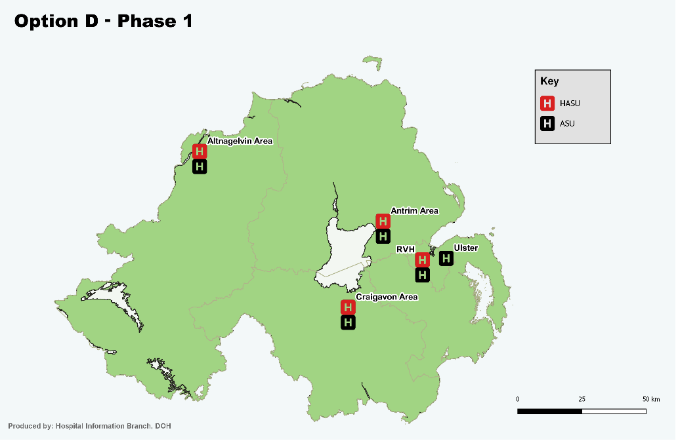  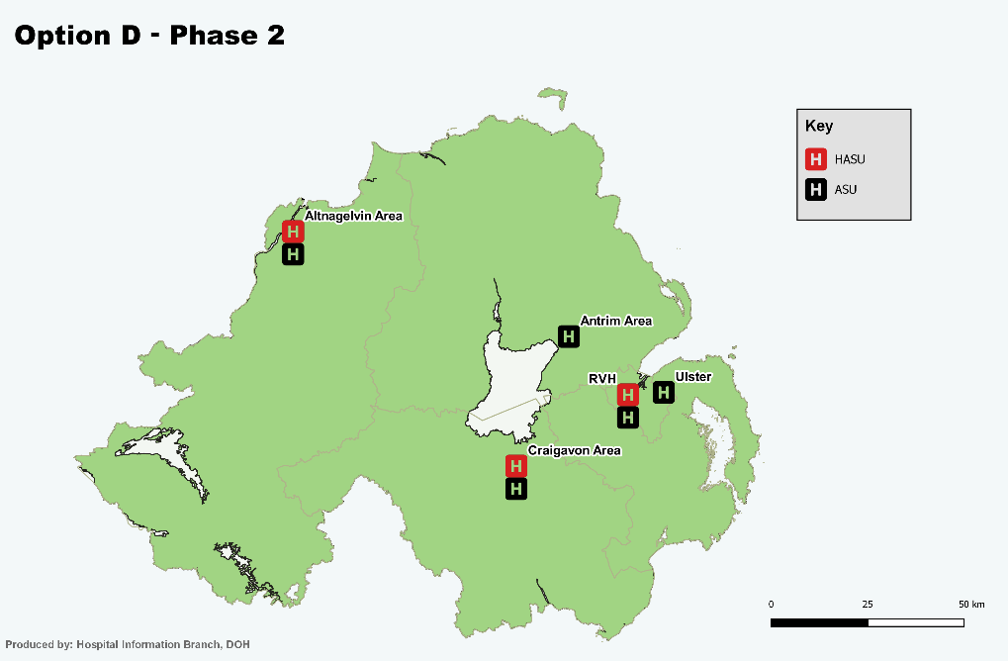
Travel time to a Hyperacute (Highly Specialist) Unit | Stage 1 - 94% people – the journey is less than 1 hour  Stage 2 - 93% people – the journey is less than 1 hour
Things to think about | This allows time to increase the service for more patients at the Royal Victoria Hospital  In phase 2 more patients will go to Altnagelvin so staff will develop their specialist skills

Option E  Phase 1 4 Hyperacute (Highly Specialist) Units  Phase 2 3 Highly Specialist Units  Close the unit in the South West Acute Hospital  4 Acute Stroke Units with a possible 5th stroke unit at the Ulster Hospital | Make changes in 2 phases –  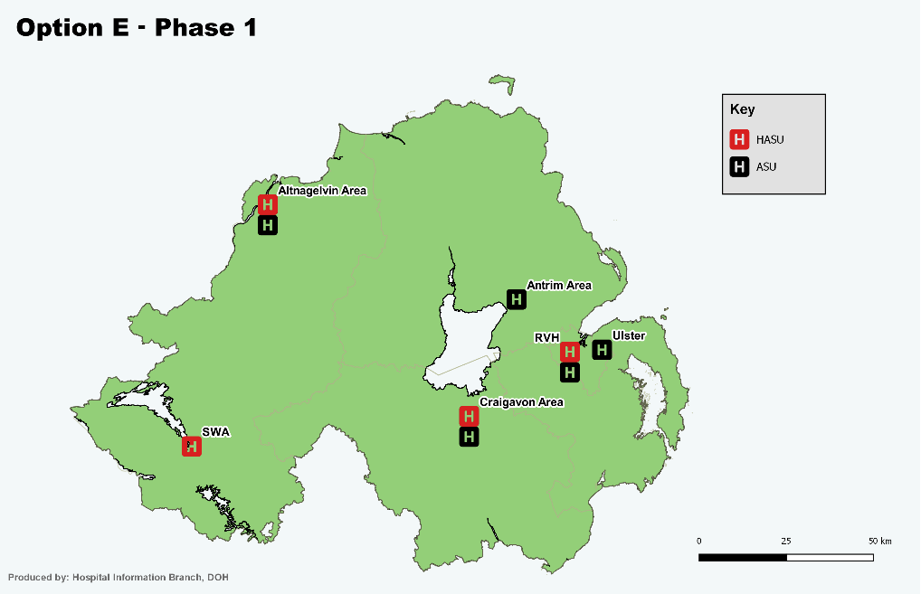  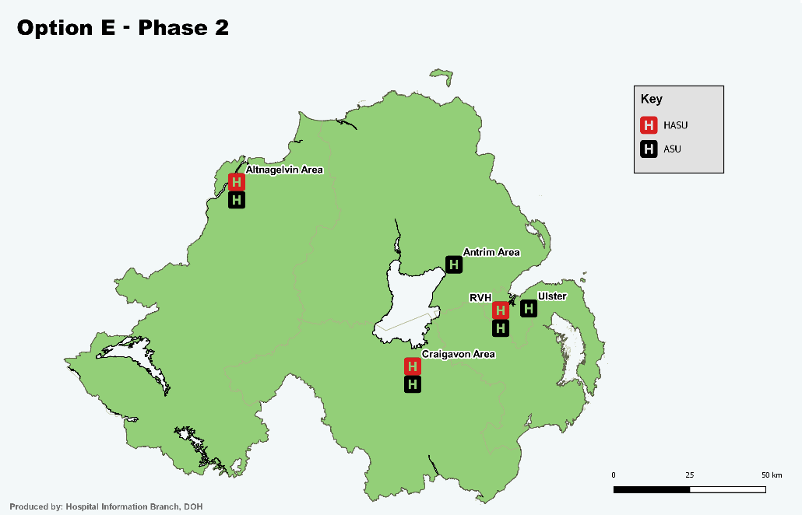
Travel time to a  Hyperacute (Highly Specialist) Unit | Stage 1 - 98% people – the journey is less than 1 hour  Stage 2 - 93% people – the journey is less than 1 hour  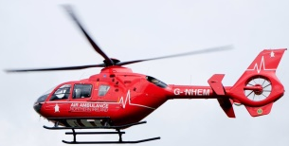  Some people will need to travel for 1 ½ hours  An air ambulance could help reduce travel time
Things to think about | None of the has the right numbers of patients - 3 have too few and 1 has too many  In phase 2 Craigavon Hospital would develop better expertise in their staff.  There is no time to plan for coping with too many patients in the Royal Victoria Hospital

Option F  3 Hyperacute (Highly Specialist) Units,  4 Acute Stroke Units with a possible 5th unit at the Ulster Hospital. | 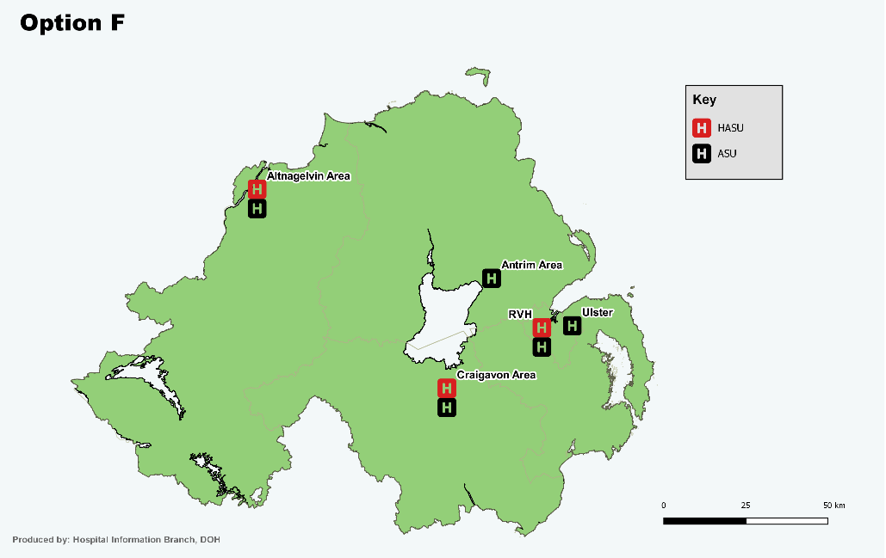
Travel time to a Hyperacute (Highly Specialist) Unit | 93% people – the journey is less than 1 hour  Some people may need to travel up to 2 hours  An air ambulance could help reduce travel time
Things  to think about | The Royal Victoria hospital will be too busy  This option depends on providing more staff and beds to help it cope  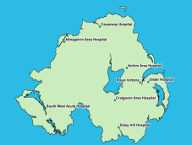  This is the best option for the Altnagelvin hospital
Tell us which option you like best

A | B | C | D | E | F

Tell us any other ideas for how we could make the changes.

Thank you your views will make a difference

There is more information on our website

www.health-ni.gov.uk/consultations/reshaping-stroke-care

