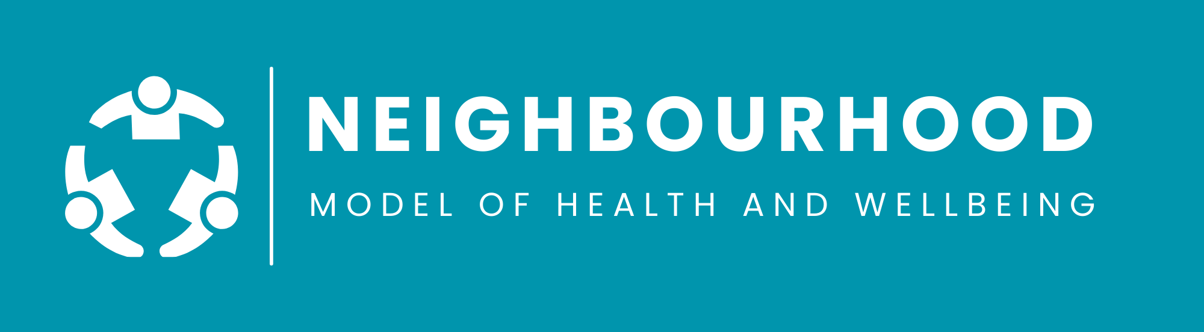
ANNOUNCING THE PUBLICATION OF THE VISION FOR
NEIGHBOURHOOD HEALTH AND WELLBEING IN NORTHERN IRELAND
On 31 March 2026, the Health Minister announced the publication of a policy framework outlining the Vision for the Neighbourhood Model for Health and Wellbeing, marking the beginning of a major shift in how care will be delivered across Northern Ireland. This new framework charts a clear, long‑term direction focused on prevention, early intervention and bringing more care closer to home.
The Neighbourhood Model sets out an ambitious approach to transforming health and social care that aims to deliver more care closer to home by shifting the focus from hospital to community-based care and services. At its core is the establishment of Integrated Neighbourhood Teams (INTs), bringing together GPs, community pharmacists, nursing, AHPs, social care, VCSE partners, councils and people with lived experience. These teams will work as local alliances, focused on improving access, strengthening continuity and supporting people to live healthier, more independent lives in the places they call home.
Development of the model has been shaped by stakeholder engagement, and 183 submissions were received through a Call for Evidence, providing real‑world insight from practitioners, partners, service users and community organisations. These contributions have played a significant role in informing the approach. NI Neighbourhood Model of Care - Call for Evidence - Summary Report.pdf.
Alongside the call for evidence report, the Department has now published the policy framework, setting out the long‑term vision and the four pillars underpinning the model. Neighbourhood Model of Health and Wellbeing in Northern Ireland - Policy Framework - March 2026 - PDF.
A dedicated NI Neighbourhood webpage is now live, offering further information and Frequently Asked Questions: https://www.health-ni.gov.uk/publications/neighbourhood-model-health-and-wellbeing.
We encourage all stakeholders, HSC staff, service providers, community partners and individuals to sign up here for future newsletters and updates. This will ensure you are kept informed as implementation progresses, milestones are reached and opportunities for engagement arise.

