POST PROJECT EVALUATION

Name of organisation | SPPG
Project Title | Oral Surgery Pilot PDS Scheme 2022/23
Total Cost | £778k
Start date | 1 April 2022
Completion date | 31 March 2023
PPE Due Date  (Per associated Business case) | Asap - Required to progress business case for 2023.24
PPE Completed by | Diane McKillen, Project Manager
Signature and date | Diane McKillen, 24.3.23
SECTION 1: INTRODUCTION
Background (a brief description of the project and its objectives)

[expand as appropriate]

Since it was first implemented in October 2017 the aim of the Oral Surgery PDS Pilot has been to sustain a service to patients who require oral surgery at a level of complexity that is beyond the competency of their general dentist but is not sufficiently complex to require referral to secondary care.
Long before pilot implementation this service has been delivered within Primary Care by 6 High Street Oral Surgery (HSOS) practices. General Dental Practitioners (GDPs) refer patient to these practices where they are treated by a mix of specialist and non-specialist oral surgeons. However, HSOS capacity is constrained by a shortage of oral surgeons.
In 2016/17 the 6 HSOS practices treated a total of 11,869 unique patients at a cost to the GDS budget of approx. £1.1million. This volume represented an activity decline of 30% since 2013/14. The decline was attributed largely to non-viable remuneration arrangements for the HSOSs and a move to them treating more private patients. The activity decline resulted in the following:
• Increased HSOS waiting lists and waiting times of approx. 6 months.
• Increased demand on hospital Outpatient Oral Surgery services where numbers waiting were already in excess of 8,000 patients with many of these for more than 52 weeks.
• Inappropriate GDP referrals – low complexity patients suitable for treatment in HSOS but referred to hospital due to access issues.
• Financial inefficiencies – Oral Surgery patients seen in a hospital setting cost multiple times more than in an HSOS setting (an average patient cost of £90 in Primary Care compared to £521.94 in Secondary Care).
• Sub-optimal use of hospital resources which should only be used to treat the most complex cases.

Pilot Evaluation Prior to Covid-19

2019/20 evaluation of the pilot demonstrated that from the outset in October 2017 the pilot had successfully met its objectives resulting in a range of positive outcomes:
• Increased activity within Primary Care across NI (currently by more than 30%).
• A wider and more consistent range of level 2 treatments being provided.
• HSOS waiting times of 8-10 weeks instead of 6-8 months.
• Re-referral by GDPs to HSOS practices of patients waiting on long Trust waiting lists.
• Patients are less likely to be waiting in pain for treatment and are less at risk of serious oral health deterioration during this time.
• A reduction in GDP referrals to secondary care of approximately 23%.
• Positive feedback from patients, GDPs, the BDA and from Trusts.
• Much lower treatment costs than in secondary care.
• Trust resources can be better utilised on treating the most complex cases.
• The remuneration model can be easily adjusted to reflect patient demand and provider capacity, provides greater budgetary control for the commissioner and spend can be accurately predicted.

In view of the positive outcomes the sustainability of the HSOS service was seen as essential and to reflect this view, as part of a rebasing exercise in 2020/21, DOH allocated a recurrent £700k as part of the GDS budget to the Oral Surgery PDS Scheme

During the 2020/21 pilot period the Covid 19 pandemic had a severe impact on Oral Surgery. In 2020/21 activity was only 25% of that in the previous year (3971 patients treated in 2020/21 compared to 16,087 in 2019/20). However, it was acknowledged that without the pilot the only options for the thousands of patients on the Oral Surgery waiting lists were either to pay privately (which many cannot afford) or be added to secondary care waiting lists. Hospital oral surgery services have also been significantly impacted by the pandemic restrictions and do not have the capacity to treat these patients. To prevent an access issue for patients and longer hospital waiting lists a business case was therefore approved for 2021/22.
Beyond March 2022 the intention was to implement a three-year Oral Surgery scheme. This would address complaints from HSOS practices that a 12-month contract did not provide them with the certainty they required to plan their business and made it difficult to recruit pilot performers. DoH indicated support for this move. However, given the uncertainty of the market as a result of the pandemic it was considered prudent to delay this for a further 12 months until April 2023.
The IPT for 2022/23 sought approval to spend £778k of recurrent funding on an extension of the existing Oral Surgery PDS Pilot for a further 12-month period from 1.4.22 until 31.3.23, ideally with a three-year scheme to follow from 1 April 2023. Costs were calculated at an increased per capita specialist allowance fee of £80 per patient subject to achievement by the practice of agreed patient volumes by year end (equating to approximately £169 per patient including SDR treatment fees which do not form part of the pilot and the business case).
An expression of interest was also to run in April 2022 to try to attract new specialist oral surgery practices to the scheme.
Please give details of commencement of scheme, when staff were appointed and when full capacity was achieved.
[expand as appropriate]

The PDS Pilot scheme for Oral surgery has been in operation since October 17 and has had a number of extensions with no break in service. The current phase runs from 1 April 2022 to 31 March 2023.

The same pilot team has been in post for a number of years.

SECTION 2: ACHEIVEMENT OF OBJECTIVES

Did this Investment meet objectives given in Business Case? Please give details.
Objectives | Were they achieved? | How were they achieved?
1. To Continue to Provide Patients with improved access to Oral Surgery Services within Primary Care until a permanent solution is devised. | Yes | The oral surgery pilot ran from 1 April 2022 and will continue until 31 March 23.
2. To run an Expression of Interest exercise in April 2022 to try to recruit new pilot performers | Yes, in that an expression of interest was issued on 12 April 2022 (as soon as the business case was approved) to try to recruit new providers | The exercise was unsuccessful in that no new practices were recruited. There were two interested private practices but ultimately, they decided that they were not ready to participate.
3. Options should be capable of meeting a minimum annual activity target of approximately11K Patients. | Objective was achieved in part. | Providers were offered patient volumes of 11k patients however due to a lucrative private market and limited capacity they prioritised private patients. By year end they are will have treated an estimated 7.6k Health service patients.  (based on February 23 actual figures of 7038).  Practices indicate that despite an increase in specialist allowance for 2021/22 (as negotiated with DOH and equating to a fee per case of approximately £179 per case) the fees were less than they had requested (£200 per case) and are not sufficiently attractive to prevent them prioritising private patients over health service activity.  Although at 7.6k activity is sub-optimal without the pilot scheme activity would have been minimal. Even at increased rates 1 of the 6 pilot providers opted out of the scheme. A potential 16K patients would potentially have been referred to secondary care - 7.6k patients treated in 22/23 plus 8.4k on provider waiting lists. As there are currently 12k patients already on secondary care waiting lists with many patients waiting more than 2 years this would be highly undesirable

SECTION 3: COSTS – PLANNED VERSUS ACTUAL
Costs planned in original Business Case | Actual Costs  (Please comment on variances etc.)
The recurrent annual budget is £778k | Pilot spend was £733k. This is less that the £778k funding due to lower than anticipated activity.  The average payment per patient including SDR fees at usual rates plus pilot enhancements was costed in the business case at £169. The actual average spend per case is currently £167.76 (this varies depending on casemix).

Were actual costs equal to planned costs? If no, please provide reasons for the variance.
Minimum and maximum activity targets were agreed with each practice according to their capacity and budget availability. They have already met minimum targets but will not achieve maximum.

SECTION 4: TIMING PROFILE – PLANNED VERSUS ACTUAL
Timing profile planned in original Business Case – eg start date, milestones, completion dates etc | Actual Timing Profile  (Please comment on variances etc.)
Start date was 1 April 2022 | Start date was 1 April 2022 – no variance
End Date 31 March 2023 | End Date 31 March 2023 0 no variance

Did actual timing profile meet planned timing profile? If no, please provide reasons for the variance.
Yes. All timescales were met. Activity was profiled by the practices across the year to ensure a consistent level of service provision.

SECTION 5: VALUE FOR MONEY

What methodology was used to assess quality and value for money of service provided? What were the conclusions?
[expand as appropriate]

The monthly activity and cost reports from BSO as well as provider monitoring returns were monitored closely to ensure that practices were on track to minimum targets and that treatment provided was at the appropriate complexity level, i.e. Level 2.

The projected 7.6k patients that will have been treated by 31 March 23 means that practices met the minimum targets agreed with them in April 22. These patients would otherwise have been referred to secondary care where waiting lists are already excessive.

Activity is at the appropriate level of complexity, i.e. level 2. Referral of these patients to secondary care would mean sub-optimal use of hospital resources as these are meant for cases of level 3 complexity.

The number of patients waiting is approximately 8.4k and waiting times range from 3 to 9 months. Although for some pilot practices these are longer than last year they are still far shorter than in secondary care. Pilot practices are contractually obliged to prioritise patients according to clinical need.

Practices received £167.76 on average per patient (this varies according to casemix) and is in line with the budgeted £169 and as costed in the IPT. This is considered value for money as it is at the lower end of fees paid elsewhere in the UK. A Paper dated February 2022 showing current rates paid in the Midlands, UK. This indicates that for comparable treatments a range of £174.60 - £350 per patient was paid.

https://www.england.nhs.uk/midlands/wp-content/uploads/sites/46/2022/03/East-Midlands-Intermediate-Minor-Oral-Surgery-Needs-Assessment-2022.pdf

At a NI provider meeting in 2022 a rate requested by the pilot providers was £200 per case. At a subsequent internal meeting with GDOS DOH colleagues a payment of £169 was decided upon.

The actual average rate of £167.76 per case under the current pilot phase is far less than the cost of comparable treatment in secondary care which in 2019.20 was £521.94.

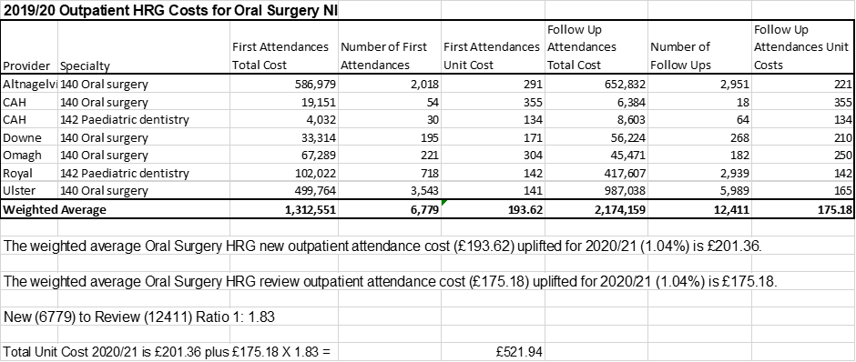

SECTION 6: RECOMMENDATIONS AND LESSONS LEARNED
What problems were encountered during implementation of the project, and how were such resolved?
[expand as appropriate]

The main problem encountered during the pilot was the reluctance of pilot providers to commit to Health Service treatment at the rates offered. It would be unwise to match pilot rates to private rates to obtain increased volumes as this would cause an unwanted shift of private patients to the Health Service. However, given that the private market is so strong and the provider practices claim not to need Health Service work SPPG has no/limited bargaining power.

Future capacity of the pilot providers will depend on the economic climate but also other factors including the size of the workforce. As this is predominantly female it can be heavily impacted by leave including maternity leave.

Discussions have been had with pilot providers regarding some contractual/operational changes which would allow them greater flexibility and may enable them to treat more patients in 2023/24 and beyond. This includes a three-year pilot contract which will provide greater security in terms of business planning and the ability to recruit and retain performers – although it is acknowledged that there is a shortage of oral surgeons in NI. It also relates to the removal of a contractual requirement for an oral surgeon to be on site at all times that a non-specialist is treating patients. A more flexible arrangement is proposed in the contract for 2023 and beyond within a robust governance framework which requires the Pilot Specialist Lead to ensure that cases are assigned to non-specialists according to their individual level of competency. This may also enable greater patient volumes.

What was learned, how has this been disseminated, and to whom? Please provide supporting evidence.
[expand as appropriate]
This information has been discussed in Pilot team meetings and at Dental Adviser meetings. It has not been shared widely as the pilot for 2022/23 is still running but is outlined in the three-year business case for 2023/24 to 2025/26.

