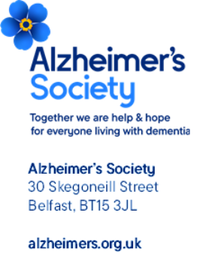
EMAIL; - neighbourhoodprogramme@health-ni.gov.uk 17th November 2025
Alzheimer’s Society is the largest dementia charity in England, Wales and Northern Ireland and we welcome the opportunity to respond to this call for evidence on Neighbourhood Model of Care. We are formally responding via the online portal with an example of successful integrated practice from the Northern Trust’s ‘Memory Link Worker Service,’ as well as using this valuable opportunity to share evidence from other nations.
Background
Dementia is a growing issue across these islands – with the largest projected increase in prevalence across the Nations to be in Northern Ireland. The number of people living with dementia is projected to increase by 51% to over 37,400 people by 2040.
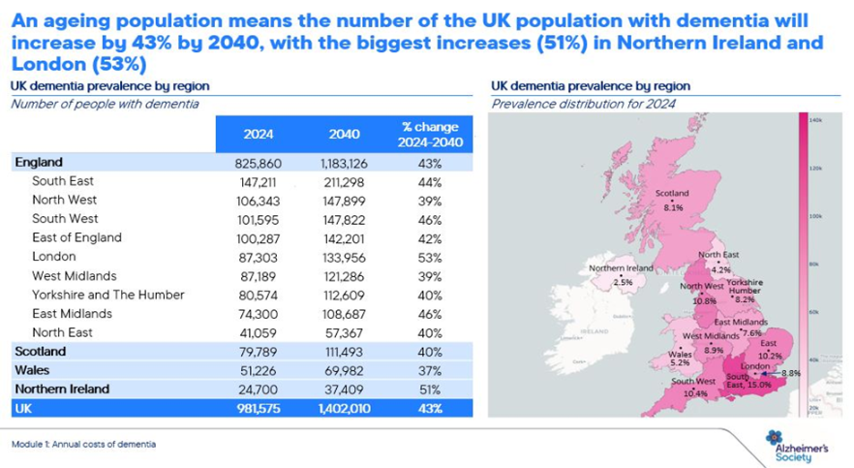
As part of this call for evidence we are keen to share our experience, insight and expertise to support the health and social care system in Northern Ireland to prepare for this increase in prevalence. Please see attached evidence of how a partnership between Alzheimer’s Society and Devon Partnership NHS Trust has benefited those living with dementia in Bristol. Prior to the partnership in 2015, the dementia diagnosis rate in Bristol was just 50%, but by March 2024, this had risen well above the NHS England target of 66.7% to 73.6%. Areas that are already delivering integrated dementia health and care services are in a good position to expand their approach to wider neighbourhood health services.
We are regularly told by people living with dementia that they want to receive care and support for their conditions at the same time and in a place that is easy to access. This is particularly important for those whose spouse or carer also requires support, with the ideal being for both to access this from the same place at the same time.
Additionally, if neighbourhood health models can help to prevent crisis through early support and lifestyle changes, this will help to reduce the number of people with dementia accessing acute or emergency hospital care. This will improve outcomes and reduce pressure on acute hospitals, helping to facilitate two of the three big shifts announced in the 10 Year Health Plan.
While we are still assessing how neighbourhood health will be delivered in England, we have identified the following elements that we believe are essential to ensure the success of neighbourhood health for dementia:
- Flexible access for crisis support, and post discharge care. People with dementia attend A&E almost a million times a year. In Northern Ireland there are over 15,000 A&E visits annually by those living with undiagnosed dementia and we also know that at any given time, almost one in six hospital beds are occupied by someone living with dementia. To relieve pressure, neighbourhood health models must be shaped to prevent crisis for people living with dementia and provide flexible access to services for individuals and families when they need it. Regular care plan reviews and care coordination both play an important role in preventing crisis. Where hospital stays are required, the model should support earlier discharge by providing ongoing care. This is particularly important as the majority of people with dementia live in the community.
- Personalised care from the doorstep. People with dementia are more likely to have multiple health conditions, therefore, their primary reason for visiting may not be related to dementia. For neighbourhood health to truly work and provide that personalised approach the following is required:
  - Personalised health records should be accessible amongst all professionals to ensure awareness of an individual’s dementia diagnosis or pre-diagnosis symptoms. This would stop the need for people to have to highlight or tell their story again. We know, for example, that 55% of people with dementia felt they would benefit from a single named contact and 41% found the diagnosis process difficult because of seeing lots of different healthcare professionals.
  - Everyone working within neighbourhood health should have access to and/or knowledge of specialist dementia support within the model. This will ensure symptoms are not overlooked and the right support is provided for that individual.

- Early identification of dementia symptoms and clear entry to a diagnosis pathway. We know the earlier someone is diagnosed, the greater the chance they can manage their symptoms. Embedding a process of identifying symptoms and providing a seamless move onto a diagnosis pathway within neighbourhood health would benefit individuals and the wider system. For example, 40% of people with dementia said the length of the diagnosis process delayed them receiving the support they needed, and 44% said the process took longer than they expected.
- Accessible venues that support people with dementia to navigate to, from and within it. This will need to include transport links, clear signage and a system that allows an individual to easily move between the medical and social care professionals on site to receive the support required.

As part of the National Neighbourhood Health Implementation Programme (NNHIP), we are working closely with one of the wave one sites, Wakefield. As this pilot develops, we would be happy to provide further insights.
We would also be happy to expand on the examples we have provided as part of the online evidence request; and can also draw on other evidence from those living with dementia and their families if you need it.
Thank you for considering our response and we look forward to working with you to improve the lives of people living with dementia across Northern Ireland.
Yours sincerely,
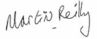
Martin Reilly
National Influencing Officer
Martin.Reilly@alzheimers.org.uk

