Neighbourhood Health Pilots
This is a pilot that ICBs and local authorities were invited to apply to, and be part of the first wave of neighbourhood health, including an ‘intensive national coaching programme’.
Those accepted into ‘wave one’ of the programme were selected for their ability to provide ‘immediate’ improvements to patients in the most deprived areas of the country, with a focus on those with long-term conditions and patients affected by wider social and economic factors.
Another of the pilot sites, Kensington, Chelsea and Westminster, already has an established integrated neighbourhood team called Octopus, which connects the health sector with the local authority and voluntary organisations.
In Sefton, where South Sefton PCN has won PCN of the year in 2024 for its collaborative work, the pilot will include community nurses and social workers working with GPs to identify those who need care early, as well as better access to healthcare for children and young people with teams ‘wrapped around schools’.
https://healthcareleadernews.com/news/the-next-steps-for-the-neighbourhood-health-service/

TV Report
"For our patients, a lot of them are poor and deprived… going to hospitals, people having to pay for parking are all barriers for people to receive care," he said.
"Most community pharmacies are within a short distance from patients' homes, and having services provided closer will make access easier and will save the cost of travelling and parking costs seen at most hospitals."
https://www.bbc.co.uk/news/articles/c78nx9744pzo

Summary and analysis of NHS England's neighbourhood health guidelines for 2025/26.
On 30 January 2025, NHS England (NHSE) published its neighbourhood health guidelines for 2025/26, outlining the priority areas and objectives for moving towards a neighbourhood health service. This is a pre-requisite to the ten-year plan to enable systems and providers to start to plan the move to a neighbourhood health service in advance of the release of the full plan in spring.
• Neighbourhood health
https://www.nhsconfed.org/publications/case-neighbourhood-health-and-care-0
aims to create healthier communities. The new guidelines are designed to help integrated care boards (ICBs), local authorities, and health and care providers progress neighbourhood health initiatives in 2025/26, before the ten-year plan’s release.
This guidance came out alongside the operational planning guidance and Better Care Policy Framework https://www.gov.uk/government/publications/better-care-fund-policy-framework-2025-to-2026/better-care-fund-policy-framework-2025-to-2026
Systems have been asked to focus initially on adults, children and young people with complex health and care needs, those who require support from multiple services and organisations. Success should: streamline access, decrease pressure on acute care, slow deterioration and additional conditions, maximise community services, improve staff and patient experience and work better with communities.
We know for this to work it will require change at every level, appropriate metrics for success, high-quality population health data and outcome-focused evaluation. All of which have been recognised by NHSE and prioritised in the guidance.
https://www.nhsconfed.org/publications/neighbourhood-health-guidelines-202526-what-you-need-know
The Department for Health & Social Care has confirmed there will be no extra funding for places in the programme but support will be offered in the form of coaches and workshops.
https://www.lgcplus.com/politics/service-reform/radical-shift-promised-for-neighbourhood-health-09-07-2025/

Example:

Neighbourhood Network Scheme
The Neighbourhood Network Scheme (NNS) is a city-wide community initiative by Birmingham City Council. It’s designed to help adults aged 50+ and adults aged 18–49 with long-term disabilities, lead healthier, happier, more connected lives.
The programme does this by supporting residents to access local services and wellbeing activities, reducing loneliness, and helping people remain independent in their own homes.
There is an NNS for each constituency in Birmingham. The programme is funded by Adult Social Care.
Birmingham Connect to Support is a city-wide online platform used by all Neighbourhood Network Schemes (NNSs).
https://www.birmingham.gov.uk/info/20057/about_birmingham/3094/neighbourhood_network_scheme
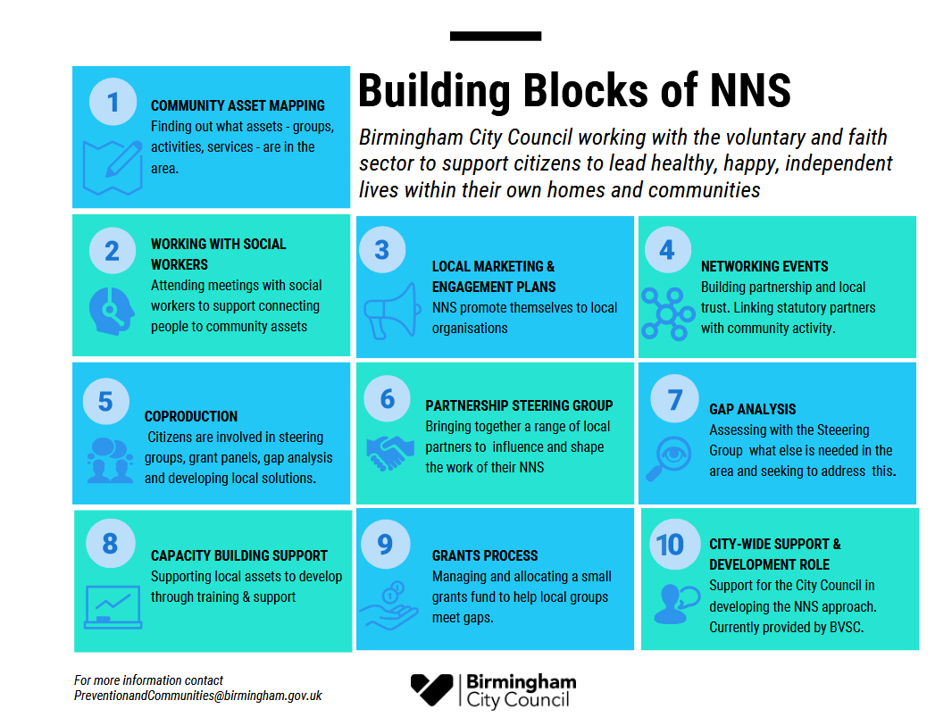
BVSC Research has undertaken an impact Assessment of NNS and the summary can be found here.
Other learning from the programme includes:
Digital inclusion - Digital inclusion-exclusion and digital poverty - NNS and PC
Support for Ethnic Minority Groups - Ethnic Minority Groups Supported by NNS and P&C Grant Holders

Timeline and Key Documents
2017 – Prevention First Strategy
New direction from 2022

In July 2022 Birmingham’s Neighbourhood Network Schemes were shortlisted in the Health and Social Care category at the Local Government Chronicle (LGC) Awards, the most prestigious award in local government.

2025 The current contracts were April 2022 -March 2027 with an optional two-year extension
https://www.bvsc.org/neighbourhood-network-schemes-in-birmingham
Doc: Laura Collins 24 Nov 25

