Progress report
Health Education Partnership Lead
Progress from beginning of Pilot Programme in June 23 – Nov 25

Our Vision
Special Schools become visible, vibrant and connected hubs within our local communities and our places, spaces and services will be equipped to include our Children and Young People in all aspects of daily living

Strategic Context
The principles of Leadership, Collaboration, Inclusion, Including the voices of Children and Young People (CYP) and Parent/Carer Involvement underpin this programme and reflect the strategic direction of travel outlined in the following frameworks and legislation. The programme also considers alignment with School Development Plans; the RAISE programme; OP2 and EA Locality profiles and UNICEF.
- New Decade New Approach OFMDFM 2020
- Children’s Services Co-operation Act (NI) 2015
- SEN Reform Agenda and 5-year Delivery Plan DE 2025
- Every Child DE 2025
- Children and Young Peoples Strategy DOH 2020-30
- PHA Corporate Plan. Priority 2- Starting Well
- A Fair Start. Final Report and Action Plan. Expert Panel on Educational Underachievement

Our Guiding Values and Principles
- We will hear the voices of our CYP using a range of communication methods
- We will embrace and protect the rights of our CYP
- We will recognise and respect the value of parents as partners
- We will value and build collaboration and co-operation
- We will build on our existing strengths, networks and good practices
- We will ensure that what we do is realistic, measurable, outcomes-focused and child centred

Programme Aim
To give our children and young people the best start in life, assist them to become progressively independent and optimise their educational, personal and life outcomes.

Objective
To work in collaboration and co-operation to increase visibility, connections and influence of Special schools across sectors, organisations and professions and provide space to hear the voice of our CYP and their parents or support networks

Key Performance Indicators
KPI 1. Create and test a cross-sectoral Hub and Spoke Model of Community Partnership and Collaboration with key partners in Children’s Services across 7 Special Schools in N.I
KPI 2. Create opportunities to hear the voices of our CYP, their parents and support networks
KPI 3. Maximise access and choices by increasing the number and range of programmes, services and opportunities for our CYP both at school and within their communities
KPI 4. Inform, influence and inspire the direction of transformation of practice and policy impacting CYP with Special Educational Needs and Disability.

Our Partners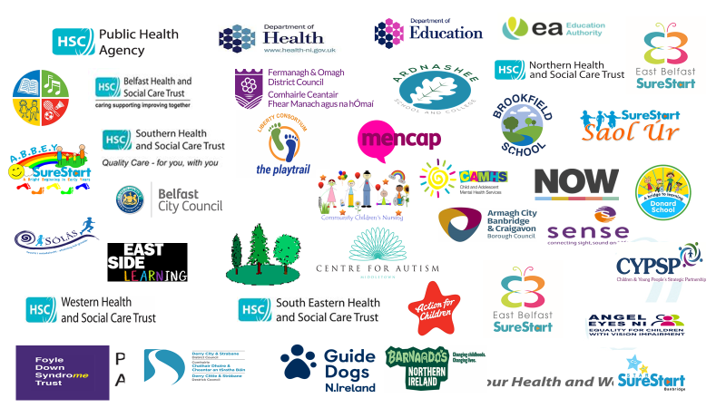
Progress
- Led, developed and facilitated Enhanced Community partnership arrangements with 7 x Special Schools
- Facilitated 42 Partnership meetings and 7 planning workshops across 7 Schools
- Successfully secured additional £234,000 to engage voices of over 200 CYP through Music Art and Play therapy using the Lundy Model of Child Participation (further details below)
- Successfully secured £10,000 to develop and deliver collaborative approach to vision impairment training across 7 Special Schools (further details below)
- Facilitated meetings with N.I Children’s Commissioner, staff, children and parents in the 7 Special Schools
- Facilitated the development of 3-year collaborative action plans developed in each pilot school (Sept ‘25-Sept ‘28)
- Led and facilitated the Regional Special School Steering group with senior partners to oversee the development and strategic direction of the Special School Partnership Hub and Spoke Model.
- Led and facilitated the development of a regional, cross-sectoral visual impairment collaboration ( NI Eye Care Network Special School Sub-group) to identify and address unmet need in Special Schools (further details below)
- Led and Facilitated the development of a regional cross-sectoral collaboration (Inclusive Respite and Recreation Forum) to improve out-of-school opportunities for children with complex disabilities (further details below)
- Parents involved as and when they can at each Partnership meeting
- Parenting Plus Special Needs training for 10 staff across 5 schools
- BEST Shared reading programme for children with ASD with 60 children
- 8 Poetry workshops held across 2 Special Schools, Poetry booklets disseminated to pupils and parent and parents and children invited to a Civic reception
- Whole school Training delivered in Clarawood by Speech and Language Therapist (including service staff)
- Whole school training (50 staff) NeuroAffirming approaches. 3 hr session delivered by Music Therapist
- Whole school training and support for pupils and parents provided by Middletown Centre for Autism and Autism NI delivered in Hill Croft, Donard and Clarawood
- ID CAMHS and Ed Psychology linked in with school team to address interventions for identified children
- Facilitated the planned school training by ID CAMHs in August in Clarawood

Engaging the Voices of Children and Young People with Complex Disabilities
- Successfully secured additional £234,000 to engage voices of over 200 CYP through Music Art and Play therapy using the Lundy Model of Child Participation
- In Oct ‘24 CYP voices heard by Ministers for Health and Education at a conference of 150 delegates which included parental presentation
- Conducted an evaluation reporting the success of this initiative
- Finalist in National Patient Experience Network Awards Oct 24
- First Prize winner in Advancing Healthcare Awards Oct 25
- Invited to present at the World Music Therapy Convention July 26
- Gave Creative Therapies a spotlight and influenced the commissioning of Music, Art and Play Therapies via the EA Counselling Contract and the SEN Agenda and delivery Plan
- Therapists, school staff and health staff collaborating to maximise impact
- Developed confidence and improved emotional well-being
- Parents have reported the positive impact at home
- Teachers have reported a positive impact in the class-room
- Teachers and classroom assistants have been able to adopt some of the learning into the classroom
- Children and young people have had their voices heard in an authentic way and developed skills and tools to express themselves
- 2 pupils discovered a previously untapped talent for Art and have been accepted by a local mainstream school for GCSE Art
- CYP’s method of communication has been enhanced, adding to their ability to make regular choices throughout the school day.

- Children with school-avoidant behaviours looking forward to going to school on days therapy happens

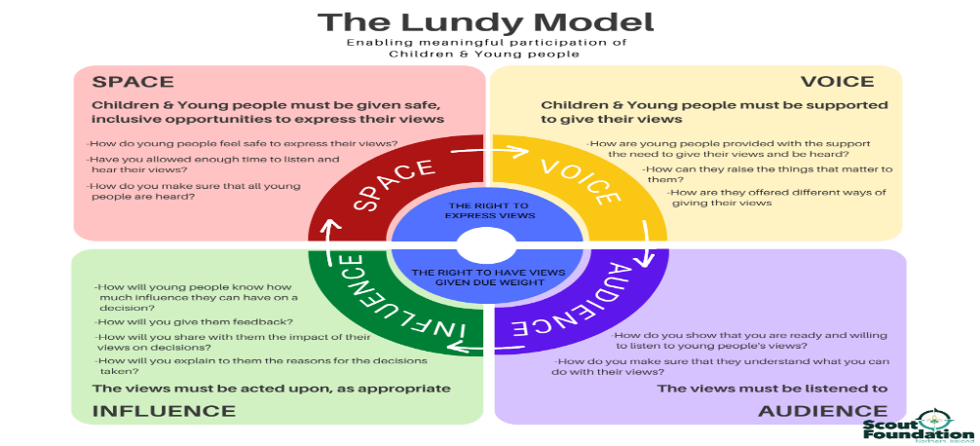

NI Eye Care Network – Special School Subgroup
- CYP in Special Schools are 10x more likely to have a visual impairment and more likely that the visual impairment is more complex than in general population of primary school children
- The cross-sectoral Regional Visual Impairment Collaboration was established through discussions at the Special School Partnerships and includes PHA, Trust Sensory Support teams, Orthoptics, Optometry, EA Pupil Sensory Support Service, University of Ulster, RNIB, Angel Eyes, Sense NI, Guide Dogs NI
- Aims to work in partnership to identify and reduce unmet need in CYP attending Special Schools and improve and maximise vision support for children and young people.
- Direct link made with NI Eyecare Network and collaborative approach to screening and vision correction raised with commissioners
- Successfully secured £10,000 to develop and deliver collaborative approach to training across 7 Special Schools
- Joint training designed and delivered by Angel Eyes NI and Orthoptics, to equip families, educators, and professionals with the knowledge and skills necessary to support children with visual impairments.
- 176 participants trained across 7 schools -129 teaching staff, 28 AHP’s, 9 parents
- 100% of participants reported increased knowledge and confidence after training
- Staff and AHPs reported practical classroom and therapy strategies gained from VR experience
- CPD accreditation added professional value
- Schools praised training as ‘superb’, ‘brilliant’, and ‘outstanding’
- Families who attended reported greater confidence in explaining their child’s condition

Inclusive Respite and Recreation Forum
- Led and facilitated the development of a regional cross-sectoral collaboration to achieve long-term sustainable change so that all children with complex disabilities have access to creative play, leisure and recreational activities outside of school hours, and in their local communities, particularly during school holidays when families face the most challenges.
- Those involved: PHA; DE; Trusts; Mae Murray Foundation; Disability Sports N.I; Playboard; Guide Dogs N.I ; Angel Eyes; Foyle Down Syndrome Trust; Liberty Consortium; Kids Together; Sense NI; Mencap; Lisburn Castlereagh Council; Armagh Banbridge Craigavon Council, Derry Strabane Council; Antrim and Newtownabbey Council; Belfast Council; Fermanagh Omagh Council; Cedar Foundation
- The group has completed an initial scoping of summer opportunities for Children and young people with complex disabilities
- We aim to include EA Youth Work in this forum

Next Steps
Each of the Special School Partnerships have developed 3-year Action plans with the following priorities:

School | Agreed Priorities
All Schools | - Hearing the Voices of CYP, parents and carers  - Increasing Inclusive opportunities in the community
Clarawood | - Transitions  - Parent/ Carer/ Family Support
Glenveagh | 3. Parent/ Carer / family Support  4. Training and upskilling across professions, organisations  and sectors
Hill Croft | 3. Social, Emotional, Behaviour  4. Training and upskilling across professions, organisations  and sectors
Brookfield | 3. Transitions  4. Training and upskilling across professions, organisations  and sectors
Ardnashee | 3. Parent/ Carer / family Support  4. Training and upskilling across professions, organisations  and sectors
Arvalee | 3. Parent/ Carer / family Support  4. Training and upskilling across professions, organisations  and sectors
Donard | 3. Social, Emotional, Behaviour  4. Training and upskilling across professions, organisations  and sectors

Outcomes
- Forged strategic alliances to build relationships, trust and confidence across sectors
- From these alliances, harnessed opportunities to expand skills, expertise and resources from outside of the education sector
- School staff have connected with and become aware of a wide range of supports and morale has improved
- Principals have reported that the connections and support they have gained have been invaluable to them
- Partnerships have provided a safe, blame-free forum to take solution-focused approach to solving contentious and challenging issues
- School staff have developed additional tools and skills for use in the class-room
- Partners have exchanged resources and skills
- School staff and partner organisation have increased opportunities for Training
- Collaboration has delivered greater insights and enhance understanding of the needs of our children and young people
- SEN raised on the agenda of partner organisations

Future Planning
It is our intention to scale and spread this approach incrementally to ensure all 40 Special Schools In N.I have developed Partnerships around their school, Children and Young People by 2030/31.

