Dental Access Scheme (DAS) PDS Pilot Scheme Monitoring Report
1 August 2024 to 31 October 2025
- Introduction
The Dental Access Scheme (DAS) aims to improve access to health service dental care for unregistered patients experiencing an emergency, urgent, or pressing condition during the working week. Replacing PUPAS, DAS was launched on 1 August 2024.

- Pilot Scheme Providers
On 31 October 2025, there were 37 practices participating in the scheme as follows:
LDC Area | Number of Provider Practices
Belfast | 10
Northern | 8
Southern | 9
South Eastern | 6
Western | 4
Patients are able to access the scheme by contacting these practices directly. The current list of providers, as well as further details about the scheme, are available at: https://online.hscni.net/dental-access-scheme/

- Activity
A total of 34,321 patients had been treated under the scheme by 31 October 2025 (over a period of 66 weeks).
The graph below illustrates how activity has increased significantly in recent weeks. Indeed, between weeks 24 and 29, the average number of patients seen was 823 which is 164% of the initially assumed 500 patients per week.
Activity levels for weeks 30 and 31 are expected to increase to similar levels by the time all claims have been received and processed.
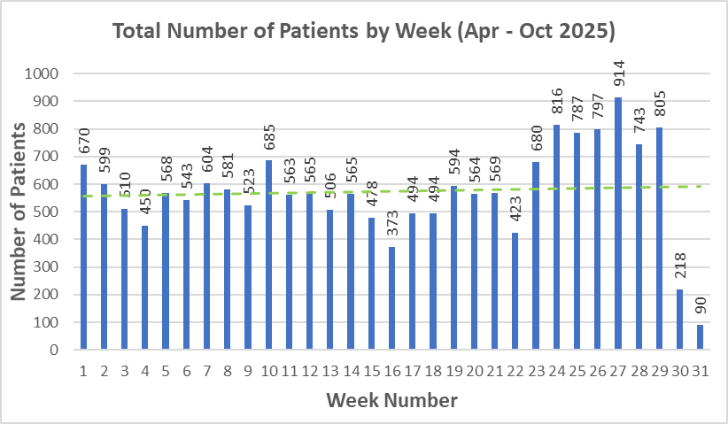

The charts below display a breakdown of activity across the various LCG areas. It is interesting to note that Belfast LCG has the lowest level of activity despite having the highest number of participating practices (ie 10). Conversely, the 4 practices from the West have treated twice as many patients as those in Belfast LCG. It should also be noted that 3 of the 4 practices in Western LCG are situated in Limavady, with the fourth in Strabane. There is therefore limited access to DAS in the Western area, with no local provision in the South West of the region.

- Casemix

Whilst the graph above illustrates fluctuation in the proportion of patients presenting with Urgent and Pressing needs, the pie chart below confirms stability with 31% of the total 34,321 patients treated under the scheme requiring urgent treatment, and 69% with a pressing need. These percentages have remained within +/-1% for many months.

The proportion of patients who were asylum seekers further decreased during October to 1.3%.

The graph below shows total activity between 1 April and 31 October 2025, broken down by urgent and pressing need. As previously stated, the lower activity in weeks 30 and 31 is expected to increase to similar levels as the preceding weeks once all claims have been received and processed.

- DAS Payments to date
The table below outlines the impact of increased activity on the budget. While, for a time, the greater number of Pressing Need claims was balanced by lower than anticipated levels of Urgent Need and Asylum Seeker claims, the budget is now increasingly overspent.

The following graph provides an alternative illustration of activity exceeding the budget on a consistent weekly basis with exceptionally high levels of spend in latter weeks, where the weekly budget is £64,000. Again, weeks 30 and 31 are expected to increase significantly once all claims are received and processed.

• Pre-payment verification of claims
All claims submitted are subject to pre-payment checks, carried out by SPPG.
Claims relating to treatment for unregistered patients are all eligible for payment. Additionally, claims relating to patients registered with a practice other than the claiming practice are also accepted, given that DAS providers have no means of checking the registration status of patients. They therefore treat patients under the scheme in good faith that they are genuinely not registered elsewhere.
If, however, the DAS provider makes a claim for one of their own registered patients, the patient is removed from the claim form and the claiming practice is notified that the patient is not eligible.

- Monitoring and Evaluation
SPPG is currently working with BSO to monitor and evaluate the scheme via the analysis of patient and treatment data.
Further information on patient demographics including registration status, costs, and other data will become available as the scheme progresses.

