- Introduction
The SHSCT was commissioned by the PHA to progress Community Strength and Balance programmes in order to:
- Reduce the falls risk of community dwelling older adults in rural and socially deprived areas;
- Increase the physical activity of community dwelling older adults living in rural and socially deprived areas.
- Use physical activity to combat and address or loneliness as per PHA Recovery Plan.

Trained Community Facilitators delivered these programmes with support from the SHSCT Physiotherapy and Promoting wellbeing staff.
Between February and April 2023, 109 people over the age of 55 years took part in ten Community Strength and Balance classes in the following community locations across the Southern Trust Area. Two areas initially identified for delivery of the programme were unable to commit to delivery during the funding period. However, the programme exceeded its target of 96 participants. On average 11 individuals attended each class and 13 individuals received one to one facilitation in the home, six time over a twelve week period.
Table 1 The Location of Community Strength and Balance Classes and number of participants
COMMUNITY VENUES | NUMBER PARTICIPANTS
BALLYSAGGART, DUNGANNON | 12
FITZONE, CRAIGAVON | 6
NAUTILUS CENTRE | 10
SALVATION ARMY, LURGAN | 14
WALD CENTRE | 13
DRUMCREE COMMUNITY CENTRE, PORTADOWN | 11
WARRENPOINT | 11
BESSBROOK | 11
LAURANCETOWN | 9
BURREN | 12

The programmes were all 10 to 12 weeks in duration. Community Facilitators were asked to evaluate their classes. At the end of the programmes 57 (52%) participant evaluation forms were submitted. 7 of the respondents were male and 50 were female.
On average 10 sessions were attended by respondents (29 individuals completed this question).
39 of the 57 respondents filled in their postcode. Table 2 below shows that participants were from the areas targeted by this project, i.e. rural and from neighbourhood renewal areas which fall within the top most deprived areas in Northern Ireland.

Table 2 Postcodes recorded by participants
BT32 | BT34 | BT35 | BT60 | BT62 | BT63 | BT65 | BT66 | BT70 | BT71
2 | 11 | 8 | 1 | 1 | 7 | 3 | 2 | 2 | 2
rural | rural | rural | rural | rural | NRA | NRA | NRA | rural | rural
*NRA= neighbourhood renewal area

Evaluation
2.1 Timed Up and Go Test (TUAG)
The TUAG test is used to determine falls risk and measure the progress of balance, sit to stand and walking. Research among community dwelling older adults in Britain found that the cut of score for falls risk is 12.6 seconds and that each one-second increase in their TUAG results in a 10% increase in a likelihood for a future fall. 20 (35%) respondents completed the timed up and go test (TUAG) on both the first and final week of the programme. The chart below (figure 2) shows that for 17 participants there was an improvement in their TUAG test that was clinically significant, demonstrating that many of these participants had made a significant difference to their falls risk at an average of 3.7 seconds.
7 out of the 20 participants whose data was collected scored less than 12 seconds at the outset of the programmes indicating they were at low risk of falls. This increased to 13 individuals scoring less than 12 at the end of the programme, indicating 6 had moved from high risk to low risk.
13 participants (65%) scored more than 12.6 at the outset of the programme indicating they were at higher risk of a fall. A 27.5% improvement in participants TUAG scores was noted (200 at the outset reduced to 145 at the end of the program).

Figure 1.

2.2 Reducing Loneliness
Another key objective of this programme is to reduce loneliness by bringing people together for exercise with the opportunity to connect socially after the physical activity session. The following question was asked as part of the evaluation. 46 participants answered the single item measure of loneliness question developed by the Office of National Statistics.

- Do you ever experience feelings of loneliness? (Select one)
Often or always
Some of the time
Occasionally
Hardly ever
Never

Figure 2. Results of Single Item Measure of Loneliness Question

It is positive to see that no participants felt lonely ‘often or always’ when the programme ended, this was a 7% reduction. The score for the percentage participants feeling lonely ‘some of the time’ increased. This is most likely a result of those who reported often or always feeling lonely at the outset improving their loneliness score. There was a 9% reduction in those reporting ‘occasional’ feelings of loneliness and a 17% increase in those reporting they hardly ever feel lonely. The score for those ‘never’ feeling lonely remained the same at 26%.

Comments by the Strength and Balance facilitators support the quantitative evidence that demonstrates the positive change in frequency of loneliness.
“The programme is invaluable to the participants. For some it is their only outing of the week and for most it’s the only exercise they do on a weekly basis. The class / group setting motivates them to get up and out that morning and they enjoy the connections they make weekly and new friendships. They all love the cuppa and chat afterwards also. It is so rewarding delivering this programme and seeing the progress made by participants on a weekly basis, and seeing them all smiling and happy during the sessions.
The participants hope it continues on an ongoing basis as this is now part of their routine and it confuses them when programmes stop and start. They look forward to the sessions and meeting their newfound friendships, for some they have formed their own break out groups and go for short walks on another morning”. (Eileen McGivern, Salvation Army and Drumcree Community Trust)
“Having observed the group form he their first day until the last, it was amazing to see the change in their body, demeanour and how that changed over the weeks. One woman who attended wasn’t able to stand straight was very down in her mood, she was experiencing pain, when she arrived on the first week. After the first week and each week after this, her posture starting to change and she started to smile more and she was getting something out of the classes. She never missed one session. We personally felt that the programme changed her.
It was so good to stand back and observe the interactions between the participants and how they were so relaxed and just chatting away to each other. I was amazed at how they were so willing to try out different moves every week.
It was more than just a Strength and Balance class for the participants, it was about social interaction, enjoyment and peer support.
Personally I really enjoyed the class and looked forward to working with them each week as we could see the difference we were making to them”. (Teresa Nugent, WALD Centre)

2.3 EQ-5D-3L
The EQ-5D-3L (European Quality of Life 5 Dimensions 3 Level Version) is a generic tool for Patient Reported Outcomes (PRO) measurement that can assess patients' quality of life, irrespective of the disease .
The EQ-5D-3L descriptive system comprises the following five dimensions, each describing a different aspect of health: MOBILITY, SELF-CARE, USUAL ACTIVITIES, PAIN / DISCOMFORT and ANXIETY / DEPRESSION. Each dimension has three levels: no problems, some problems, extreme problems. The respondent is asked to indicate his / her health state by checking the box against the most appropriate statement in each of the five dimensions.
LEVEL 1: indicating no problem
LEVEL 2: indicating some problems
LEVEL 3: indicating extreme problems.
A statistical programme (SPSS) is needed to correctly analyse this information, meaning this information cannot be accurately understood in terms of impact. An attempt to show the health states reported by 52 of the respondents has been made by calculating the average score for each health state pre and post programme. The results are shown on Figure 3 below.

Figure 3.

2.4 Self-rated Health
Participants were asked to self-rate their health using a scale numbered 0 to 100, with 100 meaning the best health you can imagine and 0 meaning the worst health you can imagine.
. We would like to know how good or bad your health is TODAY.
- This line is numbered from 0 to 100.
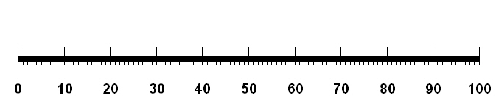
- 100 means the best health you can imagine. 0 means the worst health you can imagine.
- Please mark an X on the line that shows how your health is TODAY.

The average score for the 51 who responded to this question at week 1 was 69 and on the final week it was 80, demonstrating an average improvement on overall self-rated health of 11 percent.

3.0 Maintenance Class
It is well known that the benefits of a Strength and Balance class can only be maintained with continued practice and implementation of strength and balance activities.
When participants were asked if they would be interested in attending a maintenance class 53 answered this question. 52 (98%) of these replied yes, 1 replied no and 4 did not reply. This also may indicate the ongoing desire to participate in a group programme for social connections as well as to maintain strength and balance skills.

4.0 Permission to contact in 6 months to assess progress since class ended
When asked if they could be contacted in 6 months to assess progress since the class ended 38 (67%) said yes, 14 (24.5%) said no and 5 did not reply.

5.0 Qualitative Feedback
Comments from participants are noted below:
“Excellent, helped me post op after knee replacement.”
“I found it to be an excellent programme.”
“I have really enjoyed the programme and feel that the exercises have improved my mobility and given greater confidence. I feel fully supported by the facilitator and look forward to having the opportunity to attend future classes to maintain my strength and mobility.”
“Was great to be able to use what we learnt at home”
“The sessions have helped me in everyday life”
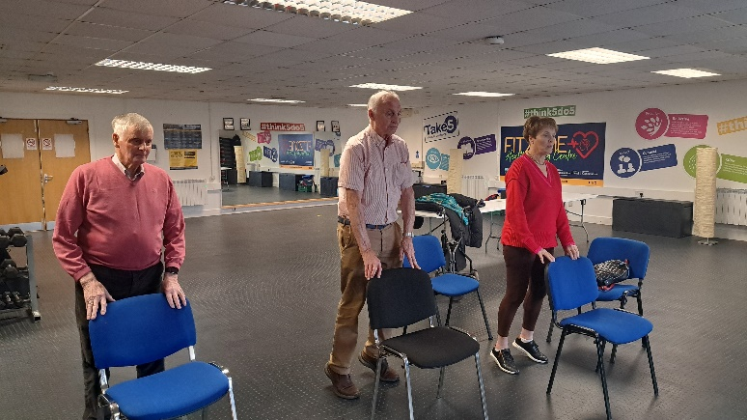
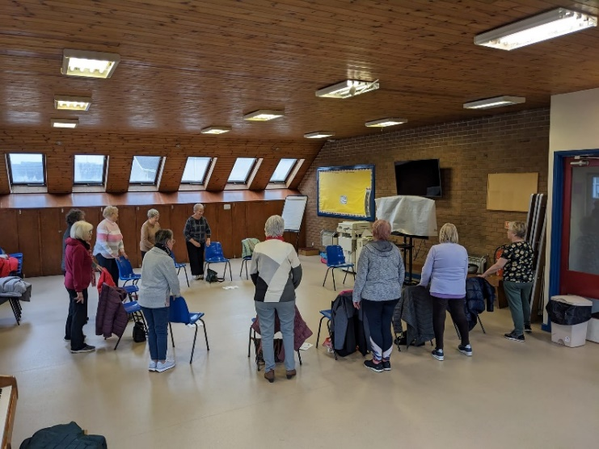
The Southern Trust Falls Coordinator has commented:
“The community programme has successfully complemented existing strength and balance delivery within the Southern Trust. This initiative has enabled us to spread the falls prevention message and strength and balance intervention to a great number of patients at increased risk of falls. This has been particularly beneficial following the COVID 19 pandemic, where we are experiencing greater numbers of older people at increased risk of falls due to deconditioning and reduced health opportunities. Due to the delivery being in local and rural communities, we have successfully targeted more vulnerable patients who were previously unable to access services due to transport and practical difficulties. It is hoped this initiative can continue to across the Trust area to other rural, isolated and socially deprived areas and that we continue to experience the great success we have achieved to date”. (Joanne McElmeel)
Conclusion
The aim of this programme was threefold.
- To further establish the Strength and Balance programme in rural areas and areas of deprivation across the Southern Trust in community settings.
- To increase access to physical activity that supports improved strength and balance
- To increase opportunity for social connection within their local communities and subsequent reduction in the experience of loneliness.

The programme has been successful in reaching those in rural and deprived areas, therefore increasing accessibility to this programme for falls prevention in areas that need it most due to the inequalities they experience because of their location in the Southern Trust area.
122 participants accessed physical activity that promoted strength and balance supporting them to work towards meeting the physical activity guidelines for adults and older adults as well as increasing the opportunity for social connections.
It is unfortunate that not all participants completed an evaluation form and that those that completed it did not always complete it in its entirety. It is hoped that through the Community of Practice coordinated by the Promoting Wellbeing Community Health Improvement Officer, that the barriers to this will be discussed and resolved going forward.
The results collated for those that did complete the questionnaires were encouraging with the results for the Timed Up and Go (TUAG) demonstrating that falls risk, balance, sit to stand and walking were improved with an average improvement of 3.7 seconds and a 27.5% improvement in TUAG for those that started the programme with a high risk of a fall. This is significant as each one-second increase in TUAG results in a 10% increase in a likelihood for a future fall.
The average scores for the loneliness self-assessment also demonstrated positive trends with the most positive outcome being the increase in participants reporting they were ‘hardly ever’ lonely (11% increase). This was further supported by the qualitative feedback from two of the facilitators. The fact that 98% stated they would be interested in attending a maintenance class would also suggest that the participants enjoyed and benefitted from the social aspect of the classes.
It is disappointing that the EQ-5D-3L information cannot be interpreted at this stage for the five dimensions of health. However, the information is collated and when access is gained to the programme that allows analysis of the results collated for each individual we can update this report. The self-assessment of health question within the EQ-5D-3L also demonstrated a positive trend, with an average improvement of 11% for the 51 participants who completed this question.
There is clear evidence of the benefits that this approach to falls prevention can result in benefits to physical, social and mental health and that it can contribute to reducing the barriers experienced in accessing opportunities for older adults being active whilst also promoting falls prevention where geographical location or socio-economic status impact chances of involvement.
Going forward the programme could be improved with recurrent funding and a dedicated staff member to support the community facilitators and co-ordinate and develop the programme further across the Southern Trust area. This approach would contribute significantly to supporting our ageing population to live healthy, independent and longer lives.

Does the timed up and go test predict future falls among British community-dwelling older people? Prospective cohort study nested within a randomised controlled trial | BMC Geriatrics | Full Text (biomedcentral.com)
A change of 0.9–1.4 seconds was identified as clinically important (ref. Measurement properties of the Timed Up & Go test in patients with COPD - PMC (nih.gov))
A-Guide-to-Measuring-Loneliness-for-Community-Organisations_Ending-Loneliness-Together.pdf (endingloneliness.com.au)
EQ-5D-3L – EQ-5D (euroqol.org)
Physical activity for adults and older adults (publishing.service.gov.uk)
Does the timed up and go test predict future falls among British community-dwelling older people? Prospective cohort study nested within a randomised controlled trial | BMC Geriatrics | Full Text (biomedcentral.com)

