Connecting Together: Strengthening Collaboration between Western Family Support Hubs, Primary Care Multi-disciplinary Teams & Western Locality Planning

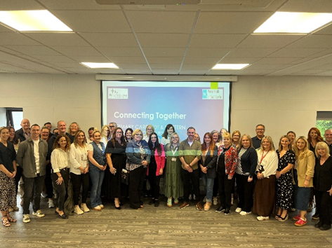

In June 2025, a significant collaborative effort—the 'Connecting Together: Strengthening Collaboration between Western Family Support Hubs, Primary Care Multi-disciplinary Teams & Western Locality Planning' was launched. Its inaugural launch took the form of a collaborative coffee morning designed to improve relationships between eight Western Family Support Hubs (FSHs), the Western Primary Care Multi-disciplinary Teams (MDTs) and Western Locality Planning. The primary objective was to foster enhanced cooperation, streamline referral processes, and encourage integrated service delivery for children, young people, and families across the area.

Recognizing that many families encounter multiple complexities (social, emotional, health-related) that cannot be addressed by a single agency, the aimed was to bring statutory, community, and voluntary sector partners together in a shared space for both formal and informal engagement. The coffee morning was intentionally structured to:

• Facilitate cross-team networking and relationship building
• Identify overlaps, gaps, and opportunities in service provision
• Share examples of good practice and innovation
• Develop consensus around next steps for integrated working.

The Collaboration was planned in response to an increasing demand for multi-agency approaches, particularly given the region's demographic profile and the known challenges in service navigation by families. The event attracted over sixty professionals across health, social care, and community development, reflecting widespread commitment to partnership working.

A hallmark of the Collaboration was its multi-agency scope. The main partner groups delivering presentations, facilitating group work, and participating in discussions included:

• Western Family Support Hubs (FSHs)
• Primary Care Multi-disciplinary Teams (MDTs)
• Social Work Teams
• Health Visiting Personnel
• Mental Health Leads
• Locality Planning Groups LPGs)
Each of these stakeholders holds a distinctive but complementary role within the overall system of early intervention, child and family health, social support, and community planning.

Western Family Support Hubs:
Family Support Hubs are multi-agency networks that coordinate early intervention services for children, young people (aged 0-18), and their families at risk of poor outcomes or marginalization. In the Western Area, each of the eight Hubs is hosted by a designated lead agency, accountable for accepting referrals, signposting, and case coordination. Core objectives include improving access, reducing duplication, and ensuring families are matched with the right service at the right time.

Key operational features:
• Voluntary, community, and statutory partners form the Hub network
• Hubs do not themselves deliver direct intervention, but coordinate and refer to appropriate providers
• Referrals accepted from GPs, health visitors, schools, social workers, and self-referrals
• Consented, family-led participation is mandatory
• Service mapping and reporting of unmet need to regional outcomes and locality planning groups

Primary Care Multi-disciplinary Teams (MDTs) in Western Trust
MDTs are a transformation initiative within Northern Ireland, designed to enhance access to holistic health and social care within primary care settings. In the Western Trust, MDTs are comprised of:

• Social Workers and Social Work Assistants
• First Contact Physiotherapists
• Mental Health Practitioners
• Health Visitors and District Nurses

MDTs emphasize capacity-building within GP practices, focus on prevention and early intervention, and reduce unnecessary referrals to secondary care services. The approach leverages co-location, data-driven triage, and proactive identification of need.

Locality Planning Groups
Locality Planning Groups (LPGs) serve as sub-structures of the regional Children and Young People’s Strategic Partnership (CYPSP), tasked with engaging communities in identifying local need, aligning resources, and supporting outcome-based planning. Their inclusion in the event underscored the importance of demographic and data-informed service development.

Key Insights from Each Partner Group
At the heart of the coffee morning were presentations from the five core service areas. These established a shared understanding of each team's remit, challenges, and innovations. Notable examples included:

• Joint Home Visits: In several areas, health visitors and social workers conducted home visits together, integrating health/developmental screening with safeguarding and practical support—resulting in better engagement and more comprehensive family plans.
• Digital Shared Referral Tools: One locality piloted a digital referral and case management platform, allowing referring professionals, Hubs, and MDTs to monitor cases and reduce delays and repetition.
• Co-facilitated Parenting Groups: Parenting programs jointly run by MDTs and Family Support Hubs achieved higher rates of sustained attendance and more positive self-reported family outcomes.
• Flexible, Community-Based Workshops: Parent engagement increased when programmes were held in accessible venues, at flexible times, and included content co-designed with parents.
• Peer Coaching Models: Drawing on evidence-based interventions, joint training and peer coaching between early years practitioners and health visiting staff significantly improved practitioner confidence and parent engagement.

Good practice invariably arose from cross-sector dialogue, genuine co-production, shared data infrastructure, and a willingness to innovate at the locality level. Success was most sustainable where leadership, culture, and resources enabled such partnership working.

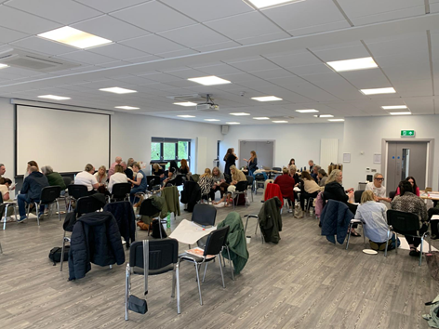

Lessons Learnt Process
A structured ‘lessons learned’ process followed the interactive group discussions, and was consolidated as part of the event’s final plenary session.

1. Communication and Relationship-Building are Fundamental
Regular, informal, and structured engagement across agencies is essential for relationship and trust-building. Face-to-face connection, such as that achieved through joint coffee mornings, accelerates relationship development—countering the fragmentation often cited in multi-agency work.

2. Shared Understanding of Roles, Thresholds, and Referral Pathways
Clarity around what each agency offers, and which referrals are best directed where, reduces both duplication and service gaps. Shared training and joint documentation are required to embed this understanding.

3. Importance of Data-Driven Locality Planning
Reliable, locality-specific data enable targeted, responsive service innovation and avoid “one-size-fits-all” pitfalls. Local planning groups are instrumental in analysing and actioning this data, with improvement monitored and shared across boundaries.

4. Need for Coordinated Digital Infrastructure
Digital tools enabling seamless referrals, shared care plans, and real-time feedback loops (with appropriate information governance) are critical for both case management efficiency and improved family experiences.
5. Cultural Competency, Flexibility, and Trauma-Informed Practice
Service design and delivery need to adapt to the cultural, linguistic, and trauma histories of local populations. Trauma-informed and neurodiversity-aware practice was highlighted as an area for system-wide professional development.

6. Sustained Leadership and Resourcing
Innovations and integrated ways of working require ongoing leadership buy-in, appropriate resources (financial, personnel, data management), and dedicated cross-agency coordination time. The risk of partnership fatigue is real if such support is lacking.

These lessons reflect both the challenges and breakthroughs of multi-agency collaboration, emphasizing that relationship, trust, and clarity are as important as process redesign.

Outputs and Actions From Connecting Together: Strengthening Collaboration

The outputs and actions resulting from this Collaboration initiative provide a clear blueprint for embedding sustained, effective, and innovative collaborative working practices across the Western Trust.

The "Connecting Together" initiative of June 2025 stands as a model of multi-agency partnership in action—moving beyond rhetoric to structured, data-driven improvement. The event exemplified best practice by:

• Bringing together diverse voices with a common goal
• Harnessing locality-specific data
• Mapping both strengths and gaps without blame
• Centreing the lived experience of children, families, and frontline professionals

With strong leadership, embedded mechanisms for ongoing collaboration, and a shared commitment to continuous learning, the Western Trust is well placed to deliver more responsive, coordinated, and impactful support for families. This initiative not only achieved its stated objectives but also provided a replicable template for similar partnerships across Ireland and the broader UK health and social care landscape.

The journey from coffee morning to culture change is underway—‘connecting together’ is not an event, but now, a way of working with locality based groups now coming together to coordinate resources & support.

