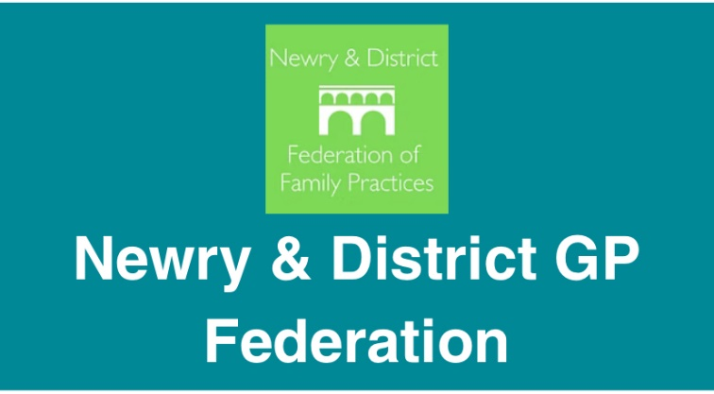

A pathway between Southern GP Federation and Advocacy VSV
Kelly Forbes will offer community development time under her job plan to Advocacy VSV. The project began in July 2024.
This project currently does not have an end date but will be reviewed periodically.
Community development is: meeting unmet needs, destigmatising mental health, working in partnership to meet local population need.
Kelly is an accredited EMDR practitioner and can support a limited number of Advocacy VSV clients per week for on-going EMDR.
Criteria has been discussed with EMDR supervisor which is set out in the intake assessment form. This is to be completed with the client and then discussed with Kelly.
This can be reviewed but criteria will be:
- Not using alcohol or substances regularly to manage symptoms or mood
- Not actively suicidal
- Not with co-morbid MH conditions that require secondary care active treatment e.g. eating disorders, bi-polar disorder
- Registered with Newry and district GP practice
- Over 18
- Not dissociative disorders
- Historical sexual abuse may be included, to be discussed further with Kelly-no current threat or current safeguarding issues involving perpetrator, social support available, some structure to day, and above criteria.
Kelly practices under the NMC Code of conduct, has a professional RMN registration whilst also being registered with EMDR All Ireland. Kelly Forbes has indemnity cover to practice EMDR.
Kelly will access clinical supervision for EMDR work undertaken with Advocacy VSV clients that is provided by GP Federation.
Referral to Kelly is via an advocacy VSV advocate only.
Kelly will link in with health professionals involved in the clients care prior to assessment, this includes GP.
Kelly has a work mobile and will communicate with clients for appointments

EMDR is a structured therapy and requires a commitment to regular sessions, home practice in between sessions and able to work within the process. Kelly will review therapy regularly with clients. If therapy isn’t progressing or doesn’t seem the right approach for the client, a review and recommendations will be provided.
If there is deterioration in mental state or increase in risk during therapy Kelly will discuss this with client, advocate, supervisor, health professionals as required. Confidentiality is maintained unless risk of harm to self or others which will be discussed with the client firstly.
Kelly will practice under southern trust safeguarding procedures.
Kelly will keep written notes of client sessions which are kept under lock and key to ensure confidentiality/GDPR.
Due to the nature of sessions and potential police investigations, notes may be requested. This would be a request to the GP Federation.
If there are complaints/concerns about EMDR therapy from advocacy of clients this can either be discussed with Kelly directly or her manager from the GP federation
November 2025

