- A brief description of the initiative
A 12 week health program with multiple stake holder involvement, and data collection pre and post program.
- The partners involved
Armagh Men’s Shed, Public Health Agency, Southern Health and Social Care Trust, Community Fund Lottery, Irish Men’s Shed, Health Habits, Armagh City Banbridge and Craigavon Borough Council, Hawthorns, and Eurospar Armagh
- Outcomes or impact achieved
95% Attendance
Combined weight loss 23.8 kgs, 94% maintained or reduced their weight
Pre-program Normal cholesterol 69% and 88% after program
Pre-program 69% normal blood pressure recording and 88% normal blood pressure with lifestyle alone
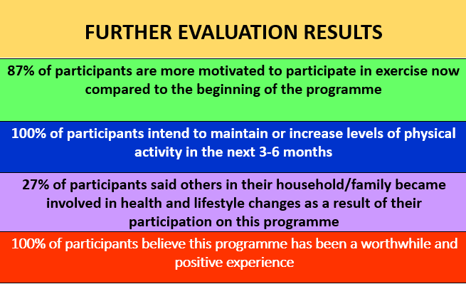
- Key lessons learned
Collective approach is the best approach. One size doesn’t fit all, so by running specific expert health care programs in already established community groups it was found to be effective. Health professional coordinating can provide a program which everyone can feels a part of and health outcomes improved.

